**SURANA COLLEGE**

BASAVANAGUDI, BENGALURU – 560004



**DEPARTMENT OF COMPUTER SCIENCE**

**A DBMS PROJECT**

**REPORT** **ON**

**“LIFE SAVER”**

**A blood bank management system**

**Submitted By**

**UDAYKUMAR N**

**(18KXSB70AB)**

And

**MAHESHKUMAR M S**

**(18KXSB70AB)**

Under the guidance of

Mrs.

Department of Computer Science

**2020-21**

**BANGALORE UNIVERSITY**

**UNIVERSITY VISVESVARAYA COLLEGE OF**

**ENGINEERING**

K. R. CIRCLE, BENGALURU – 560001



**DEPARTMENT OF COMPUTER SCIENCE AND ENGINEERING**

**CERTIFICATE**

This is to certify that the DBMS project entitled **"Appstore Management”** is a bonafide work carried out by **Vivekananda(18GAEI6056)** and **Praveen v naik(18GAEI6036)** students of **University Visvesvaraya College of Engineering** in partial fulfilment for the DBMS project in DBMS Laboratory, 5th semester, Information Science & Engineering, Bangalore University, Bengaluru during the year 2020-2021. It is certified that all the corrections/suggestions indicated for Internal Assessment have been incorporated in the Report. The mini Project Report has been approved as it satisfies the academic requirements in respect of mini Project work prescribed for the said degree.

----------------------- ----------------------

Professor Chairperson and Professor

Dept. of CSE, Dept. of CSE,

SURANA SURANA

Examiner 1:____________ Examiner 2:____________

**ACKNOWLEDGEMENT**

I take this opportunity to thank our institution SURANA COLLEGE BCAfor having given us an opportunity to carry out this project.

I would like to thank ……………….. for providing us all the facilities to work on this project. I am indebted to him for being our pillar of strength and inspiration.

I wish to place my grateful thanks to ………………..who helped me to make my project a great success.

I am grateful to……………………………….for her valuable suggestions and support, which has sustained me throughout the course of the project.

**- UDAYKUMAR N**

**(18KXSB70AB)**

**- MAHESHKUMAR M**

**(18KXSB70AB)**

**ABSTRACT**

A database represents some aspect of the real world, sometimes called the mini world or the universe of discourse. Changes to the mini world are reflected in the database. A database is logically coherent collection of data with some inherent meaning. A random assortment of data cannot correctly be referred to as a database. A database id designed built, and populated with data for a specific purpose. It has an intended group of users and some preconceived applications in which these users are interested.

A database management system (DBMS) is a collection of programs that enables users to create and maintain a database. The DBMS is a general-purpose software system that facilitates the processes of defining, constructing, manipulating, and sharing database among various users and applications. Defining a database involves specifying the data types, structures, and constraints of the data to be stored in the database. The database definition or descriptive information is also stored by the DBMS in the form of a database catalogue or dictionary; it is called Meta data. Constructing the database is the process of storing the data on some storage medium that is controlled by the DBMS. Manipulating a database includes functions such as querying the database to retrieve specific data, updating the database to reflect changes in the mini world, and generating reports from the data. Sharing a database allows multiple users and programs to access the database simultaneously.

The **“LIFE SAVER ”** a blood bank management system is a desktop application which can be used by any basic computer user to donate and recieve blood from blood bank. This application provides the access to the user to create account, send request to the donor for blood and also search the available blood samples . and also donors means hospitals can also register and donate blood to the requested users. . The main purpose of developing blood bank Management is to design an application, which could store applications data and provide an interface for retrieving users related details with 100% accuracy.

**TABLES OF CONTANT**

**1 Introduction .........................................................................................................6**

* 1. Introduction……………………………..……………………………………...6
  2. Features of DBMS…………………….………………………………………..7
  3. Objective of the DBMS……………….………………………………………..7

1. **Requirement Specification...................................................................................8**

2.1 Hardware Requirements………………..……………………………………...8

2.2 Software Requirements …………….………………………………………….8

2.3 Overview of tools…….……………….………………………………………..9

1. **Software Environment .....................................................................................10**

3.1 DBMS…………………...……………..……………………………………..10

3.2 SQL……..…………..…………………….…………………………………..16

3.3 DB Design. ……………………………….…………………………………..21

1. **System Design ....................................................................................................25**

4.1 ER Diagram………………………..…..……………………………………..25

4.2 ER Diagram for Bank System………….…………………………………….26

4.3 Components of an E-R diagram ……….. …….……………………………..27

4.4 Schema Diagram……………………………………………………………...31

1. **Results ................................................................................................................33**
2. **Conclusion ..........................................................................................................29**
3. **References ..........................................................................................................30**

**CHAPTER 1**

**INTRODUCTION**

* 1. **Introduction:**
* The **“Appstore Management”** project serves as the official appstore for certified devices running on the adroid operating sysytem,allowing users to browse and download applications.
* It also serves a digital media store offering music,books,apks or .exe files.these applications in free of charge.
* This appstore provides the access to the user to create account, Install applications or Adding the application to the appstore. Here user can browse throught diffrent app categories,view information about each app (such as rating,size of app ect.),and acquire the app.
* The software has been developed using the most powerful and secure backend **MYSQL** database and most widely used scripting language PHP.



* 1. **Features of Appstore Management** **System:**
* The proposed system is more efficient, fast, reliable, user friendly.
* Login of the developer and user using username and password there by provides security to the software.
* User can create his accounts easily by filling up details in the registration page.
* The User can install,rate the app and report about application.
* The User can add his own application as a developer by login as developer.
* The system also gives the brief detail about the apps which are in this store.
* The system also provides logout system facility.
* Manage large number of users and developer details with ease.
  1. **Objective of App store Management:**
* The main objective of the system is to install different types of applications and adding the developer’s apps to this .
* It will Reduced manual work as most of the work done by computer.
* It helps customers in suggesting the good apps to install .
* The main objective of the system is to provide a secure system. Our system is password protected and it only allows authorized user to access various functions available in the system.

**CHAPTER 2**

**REQUIREMENT SPECIFICATION**

**2.1 Hardware Requirements:**

Hardware is a set of physical components, which performs the functions of applying appropriate, predefined instructions.

The hardware requirements given here is minimal requirements for the project to run.

* Processor : Intel Pentium processor and above
* Processor Speed : 300 MHz and above
* Ram Size : 4GB or above
* Hard Drive : 32 GB or above
* Input Device : Mouse, Keyboard
* Output Device : Monitor

**2.2 Software Requirements:**

The software is a set of procedures of coded information or a program which when fed into the computer hardware enables the computer to perform the various tasks.

* Operating System : Microsoft Windows 10
* Front End : HTML, Bootstrap, PHP
* Bank End : XAMPP-sever,MYSQL
* Client side : CSS(cascading style sheet)

**2.3 Overview of Tools/Software:**

**2.3.1 XAMPP server:**

XAMPP server is a free and open source crose platform web server solution stack package developed by apache freinds,consisting mainly of the apache HTTP server, Maria DB database, and interpreters for scripts written in the PHP and perl programing language, XAMPP stands for that makes it extreamly easy for developers to create a local web server

for testing and deployment purpose.since most actual web server deployments use the same components as XAMPP, its makes transitioning from a local test server to a live sever extreamly easy as well.

**2.3.2 HTML:**

HTML stands for Hyper Text Mark-up Language, which is the most widely used language on Web to develop web pages. Hypertext refers to the way in which Web pages (HTML documents) are linked together. Thus, the link available on a webpage is called Hypertext. As its name suggests, HTML is a Mark-up Language which means you use HTML to simply "mark-up" a text document with tags that tell a Web browser how to structure it to display.

**2.3.3 Bootstrap:**

Bootstrap is a free and open-source CSS framework directed at responsive, mobile-first front-end web development. It contains CSS- and (optionally) JavaScript-based design templates for typography, forms, buttons, navigation, and other interface components. Bootstrap is a HTML, CSS & JS Library that focuses on simplifying the development of informative web pages. The primary purpose of adding it to a web project is to apply Bootstrap's choices of colour, size, font and layout to that project

**2.3.4 PHP:**

PHP is a intuitive,sever side scripting language it allows developers to build logic into the creation of web page content and handle data returned from a web browser.php also contains a number of extention that make it easy to interact with databases,extracting data to be displayed on a web page and storing information entered by a web site visitor back into the database.It is also be used for command line scripting and client GUI applications.IT requires MYSQL connection between front end and back end components to write to the database and fetch.

**2.3.5 MySQL:**

MySQL is the most popular Open Source Relational SQL Database Management System. MySQL is one of the best RDBMS being used for developing various web-based software applications. The SQL phrase stands for Structure Query Language. MySQL is a fast, easy-to-use RDBMS being used for many small and big businesses. MySQL is developed, marketed and supported by MySQL AB, which is a Swedish company.

**CHAPTER 3**

**SOFTWARE ENVIRONMENT**

**3.1 Database Management System (DBMS):**

* The database is a collection of inter-related data which is used to retrieve, insert and delete the data efficiently. It is also used to organize the data in the form of a table, schema, views, and reports, etc.
* DBMS is a collection of programs that enables users to create and maintain a database.
* The DBMS is a general-purpose software system that facilitates the processes of defining, constructing, manipulating and sharing databases among various users and applications.
* For example: MySQL, Oracle, etc.

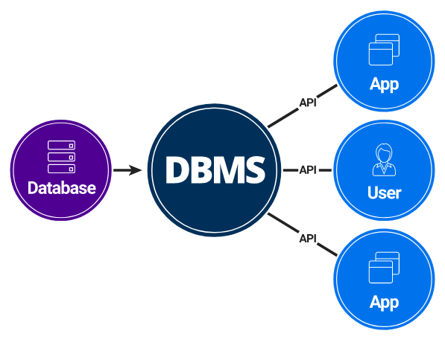

**3.1.1 Characteristics of Database Management System:**

* Self-describing nature.
* Keeps a tight control on data redundancy.
* Enforces user defined rules to ensure that integrity of table data.
* Provides insulation between Programs and data, data abstraction.
* Supports multiple views of the data.
* Helps sharing of data and Multi-user transaction processing.

**3.1.2 Advantages of using the DBMS approach:**

* Controlling the redundancy.
* Restricting unauthorized access.
* Providing persistent storage for program objects.
* Providing storage structures for efficient query processing.
* Providing backup and recovery.
* Providing multiple users interfaces.
* Representing complex relationships among data.
* Enforcing integrity constraints

**3.2 Structured Query Language (SQL):**

* It is a standard language for Relational Database System. It is used for storing and managing data in relational database management system (RDMS).
* SQL allows users to query the database in several ways, using English-like statements.
* SQL uses the terms table, row, and column for relation, tuple, and attribute.

**3.2.1 Characteristics of SQL:**

* SQL is easy to learn.
* SQL is used to access data from relational database management systems.
* SQL can execute queries against the database.
* SQL is used to describe the data.
* SQL is used to define the data in the database and manipulate it when needed.
* SQL is used to create and drop the database and table.
* SQL is used to create a view, stored procedure, function in a database.
* SQL allows users to set permissions on tables, procedures, and views.

**3.2.2 SQL commands:**

* SQL commands are instructions. It is used to communicate with the database. It is also used to perform specific tasks, functions, and queries of data.
* SQL can perform various tasks like create a table, add data to tables, drop the table, modify the table and set permission for users.

**TYPES OF SQL COMMANDS**

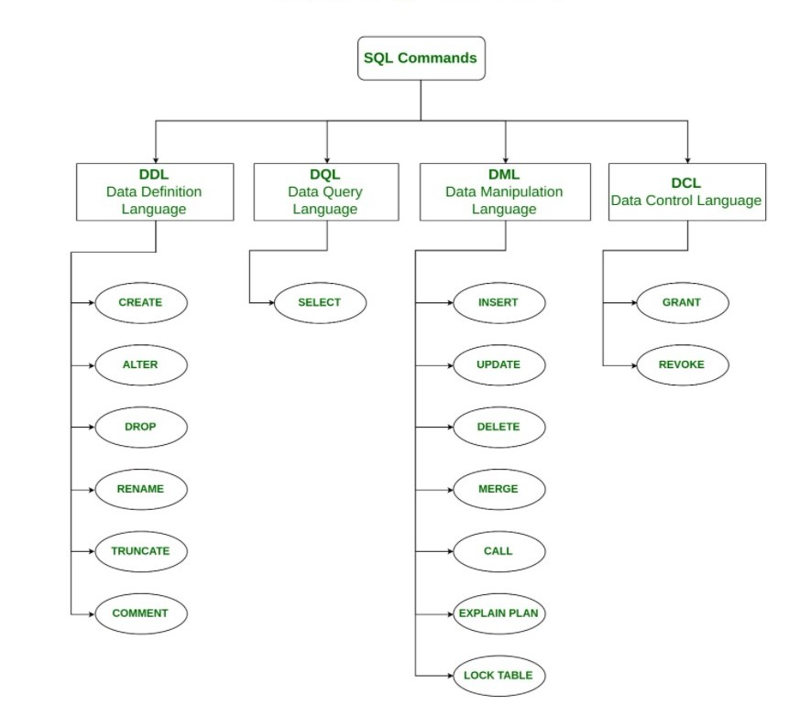

* **CREATE**

This command is used to create table or view by giving it a name and specifying its attributes and constraints. The attributes are specified first, and each attribute is given a name, a data type to specify its domain values, and any attribute constraints such as NOT NULL.

**Syntax**:

CREATE TABLE (ATR1 TYP1 CONST1, ATR2 TYP2 CONST2,)

**Ex:**

CREATE TABLE

* **ALTER**

It is used to alter the structure of the database. This change could be either to modify the characteristics of an existing attribute or probably to add a new attribute.

**Syntax:**

* To add a new column in the table :

ALTER TABLE table_name ADD column_name COLUMN-definition;

* To modify existing column in the table:

ALTER TABLE MODIFY (COLUMN DEFINITION....);

* **DROP**

It is used to delete both the structure and record stored in the table.

**Syntax:**

DROP TABLE;

**Example:**

DROP TABLE EMPLOYEE;

* **TRUNCATE**

It is used to delete all the rows from the table and free the space containing the table. **Syntax:**

TRUNCATE TABLE table_name;

**Example:**

TRUNCATE TABLE EMPLOYEE;

**3.2.3 Statements in SQL:**

Following are the important statements used in SQL.

* SELECT - Used to retrieve the information from the relation.
* INSERT - Used to insert the new values to the relation.
* DELETET - Used to delete one or more existing tuples from the relation.
* UPDATE - Used to update already existing values in the relation.

**3.2.4 Aggregate Functions in SQL:**

Following aggregate functions are provided by the SQL.

* COUNT - Returns number of tuples.
* SUM - Returns sum of entries in a column.
* MAX - Returns Maximum value from an entire column.
* MIN - Returns Minimum value from an entire column.
* AVG - Returns Average of all the entries in a column.

**3.2.5 Constraints in SQL:**

Following constraints are provided by the SQL.

* NOT NULL - Column should not contain NULL value.
* PRIMARY KEY - Should not contain duplicate or NULL values.
* UNIQUE - Each value of the column should be unique.

**3.3 Database design:**

* Database design is a collection of processes that facilitate the designing, development, implementation and maintenance of enterprise data management system.
* Properly designed database is easy to maintain, improves data consistency and are cost effective in terms of disk storage space.
* Database is designed using MYSQL database. We can efficiently store and retrieve data from the database.
* The database **LIFE SAVER MANAGEMENT** has six tables.

1. **Reciever**
2. **Hospitals**
3. **Blood info**
4. **Blood request**
5. **contact**
6. **Admin**

1. **RECIEVER TABLE**

|  |  |
| --- | --- |
| **Field** | Description |
| id | It is an auto-incremented Serial number. |
| rname | It’s contains name of the RECIVER. |
| rbg | It’s contains required blood group. |
| remail | It’s contains email of recievers. |
| rpassword | It stores the encrypted password used to log in. |
| rphone | It stores the phonenumber of the recievers |
| rcity | It stores address of reciever. |

1. **HOSPITALS TABLE**

|  |  |
| --- | --- |
| **Field** | Description |
| id | It’s an auto-generated unique ID. |
| hname | This stores the Name of the hospital. |
| hemail | This stores the email of hospital |
| hpassword | It stores the encrypted password used to log in. |
| hphone | It stores the phonenumber of the hospitals |
| hbg | It contain the available blood group. |
| hcity | It contain the address of hospital |

1. **BLOODREQUESTS TABLE**

|  |  |
| --- | --- |
| **Field** | Description |
| reqid | It contain id of requisted blood group. |
| hid | It contain hospitals id. |
| rid | It contains recivers id |
| bg | It contain blood group. |
| status | It contains thestatus of donated blood. |

1. **BLOODINFO TABLE**

|  |  |
| --- | --- |
| **Field** | Description |
| bid | It contains blood id. |
| hid | This contains the hospital id. |
| bg | It contain blood group. |

1. **CONTACT TABLE**

|  |  |
| --- | --- |
| **Field** | Description |
| id | This is the unique id auto-generated. |
| rname | This contains the name of the reciver. |
| remail | This contains the reciver mail |
| rphone | This contains the Phone number of the reciver. |
| rmessage | This contains the feedback or message about the application |

1. **ADMIN TABLE**

|  |  |
| --- | --- |
| **Field** | Description |
| id | It is an auto-incremented Serial number. |
| name | This contains the name of the admin. |
| password | It stores the encrypted password used to log in. |

**CHAPTER 4**

**SYSTEM DESIGN**

**4.1 ER diagram**

An Entity-Relationship (ER) model is an abstract way to describe a database. It is a popular high-level conceptual data model. Entity relationship diagrams (ER diagrams) are used to present the diagrammatic notations associated with ER model.

**4.1.1 Notations for ER diagram**

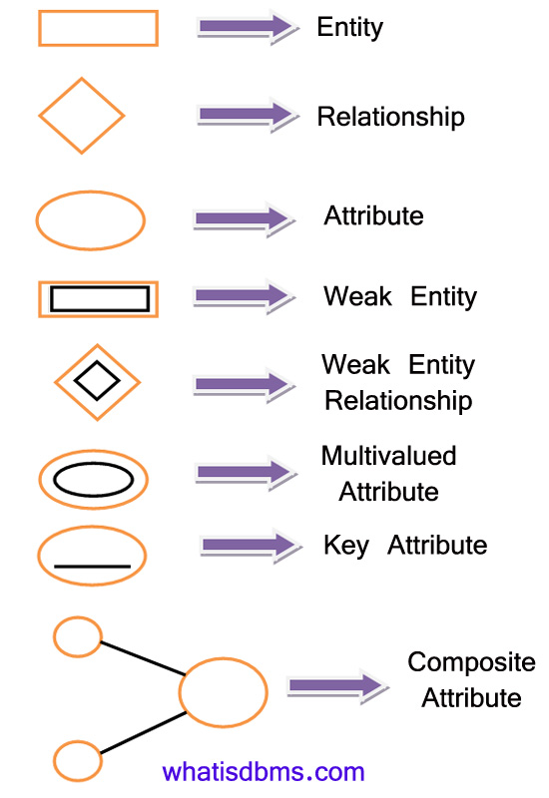

**4.2 ER Diagram for Appstore Management System:**

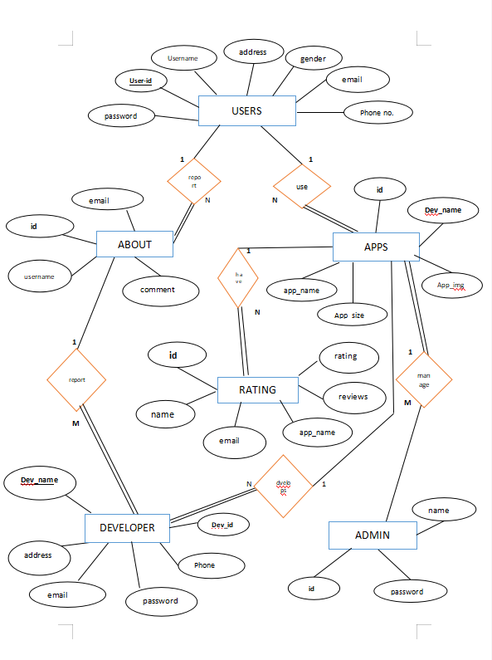

* **Schema Diagram for Housing Management:**

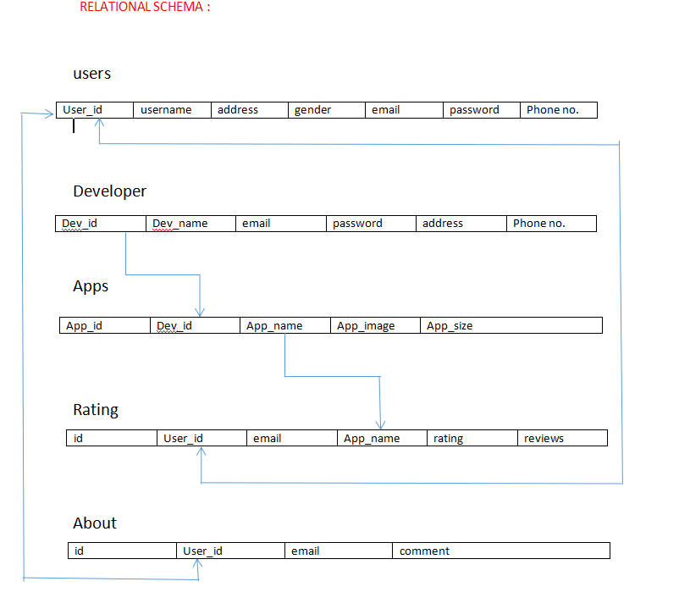

**CHAPTER 5**

**RESULTS**

**User login:**

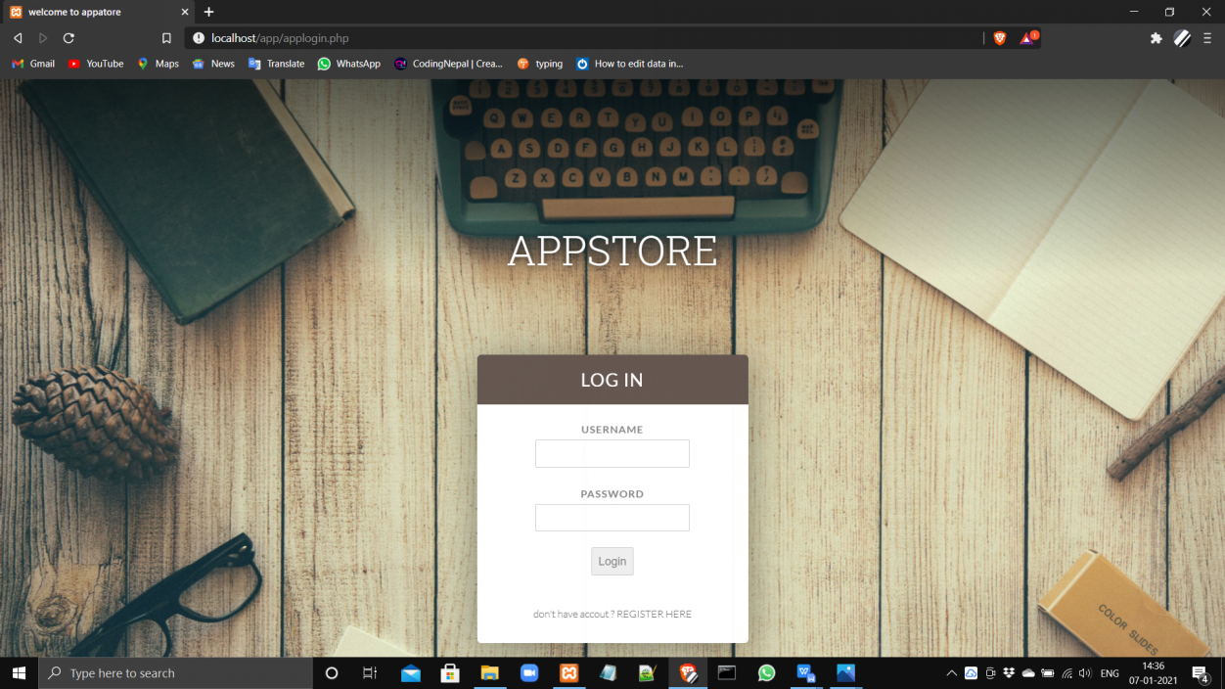

Fig 5.1 User login page

**REGISTERTION:**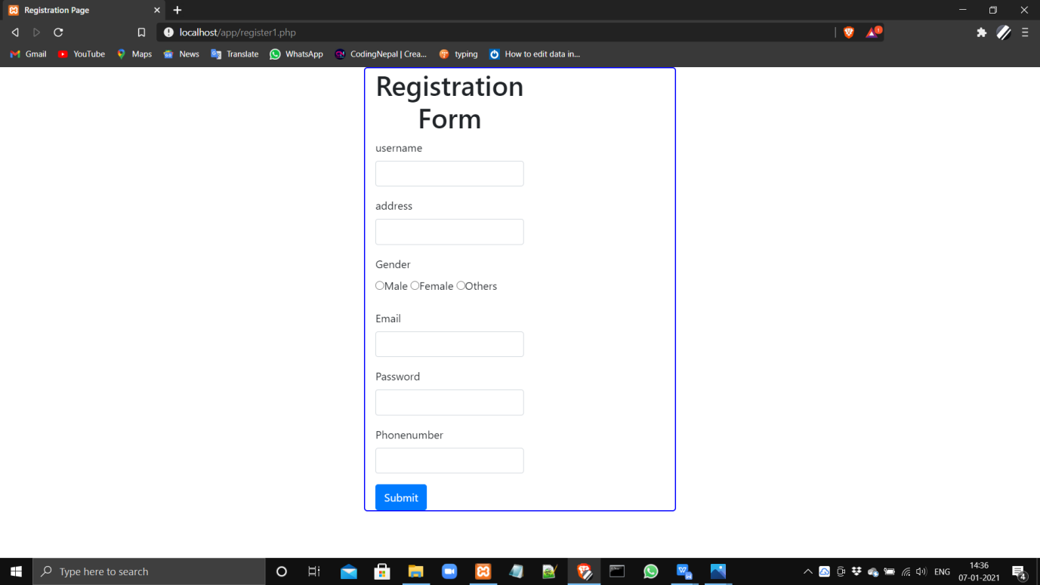

Fig 5.2 user registration form

**MAIN PAGE:**

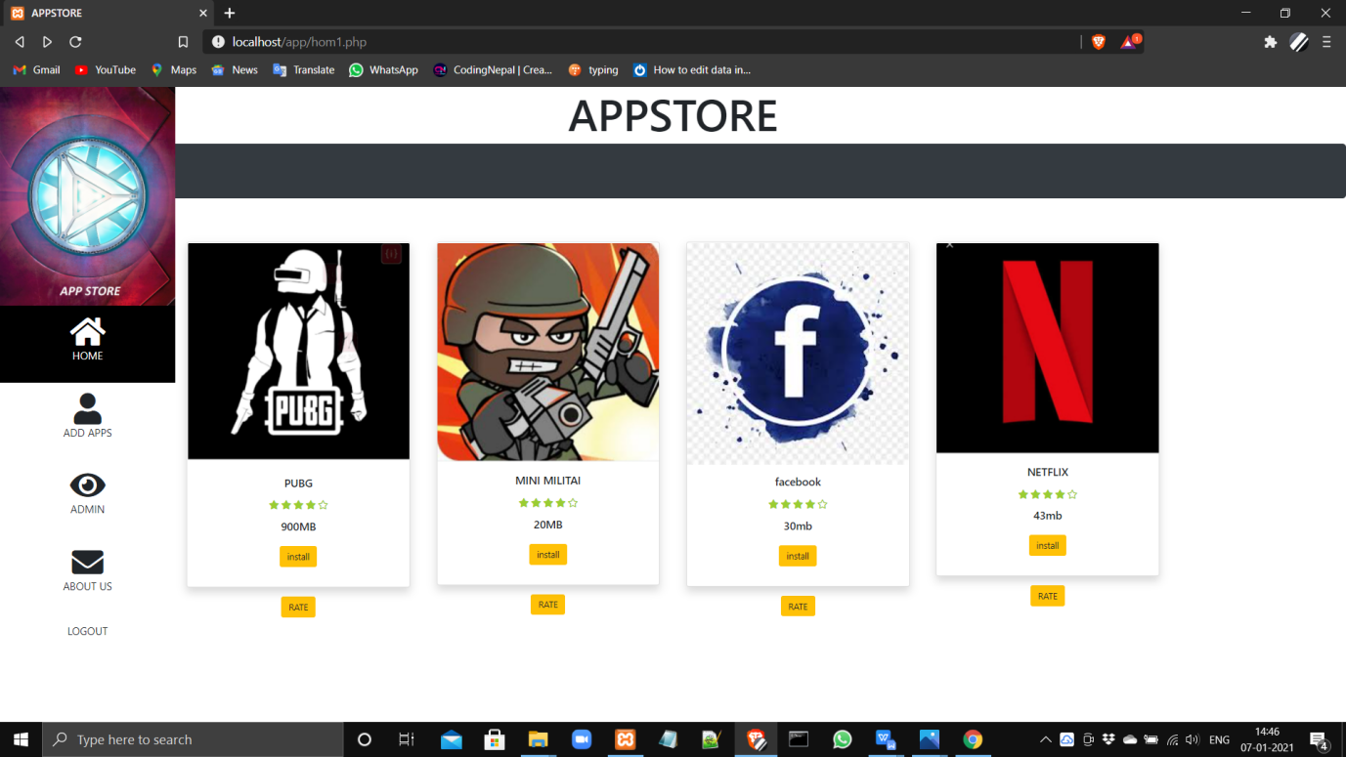

5.3 main page of appstore

**DEVELOPER LOGIN:**

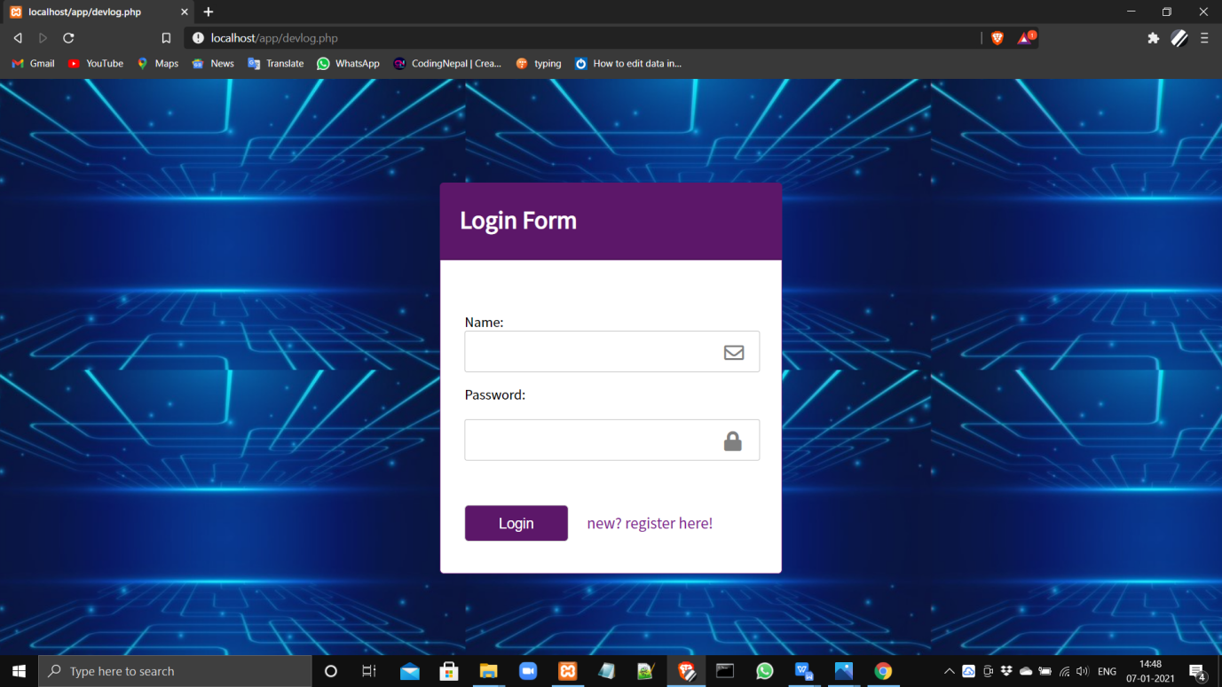

Fig 5.4 developer login page

**DEVELOPER REGISTERATION FORM :**

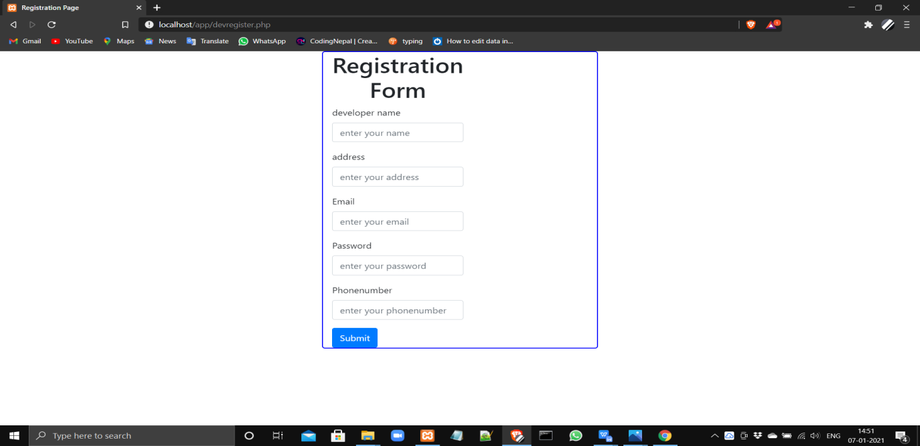

Fig 5.5 developer registration form

**UPLOADING OF APPS:**

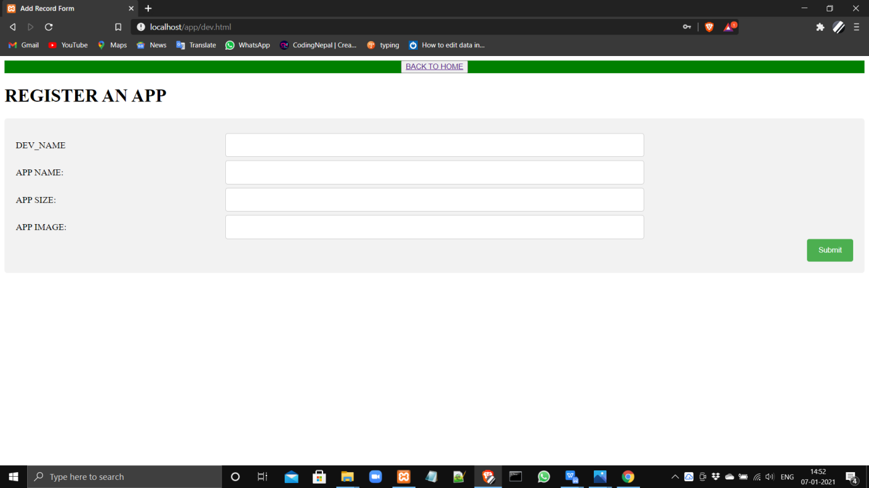

Fig 5.6 Adding of apps by developer

**ABOUT US :**

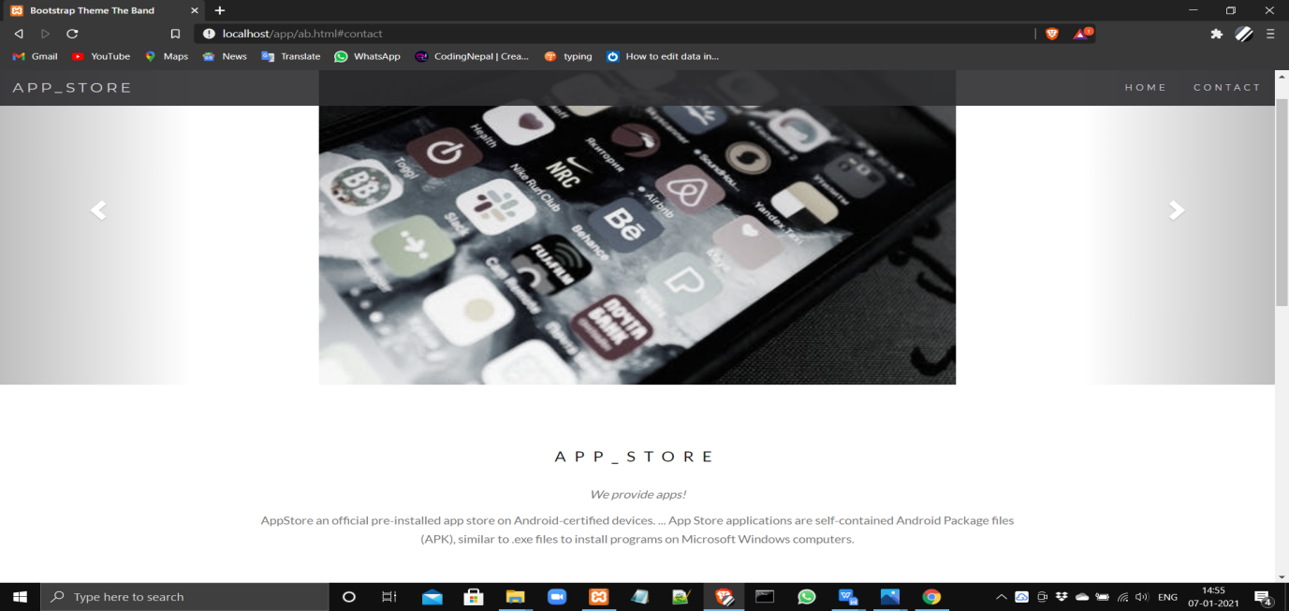

Fig 5.7 About us page of appstore.

**CONTACT FORM IN ABOT US:**

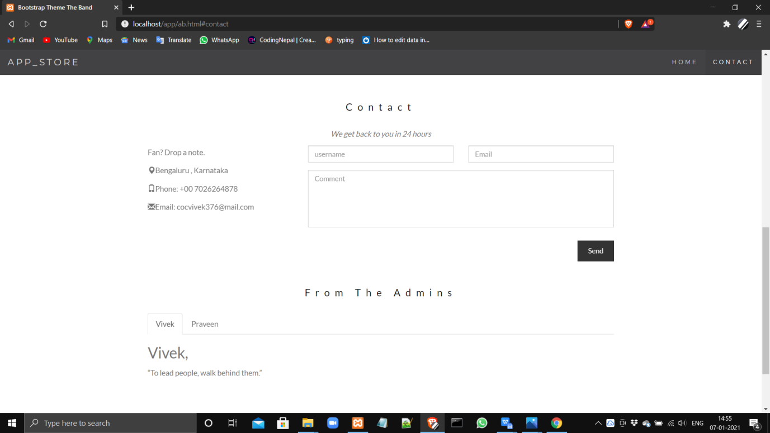

Fig 5.8 contact form

**ADMIN LOGIN PAGE :**

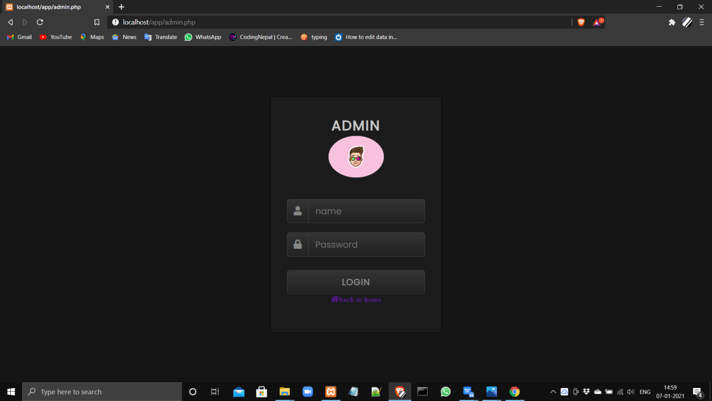

Fig 5.9 Admin login page

**ADMIN PAGE:**

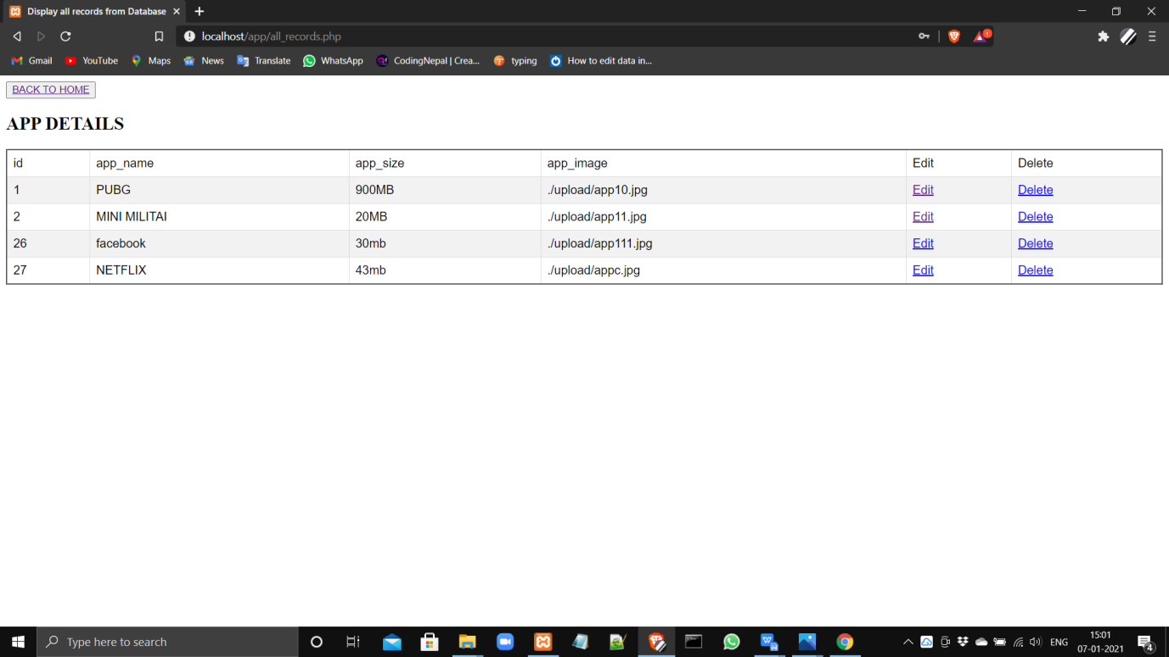

Fig 5.10 Admin panel for app edit and delete controls

**LOG OUT:**

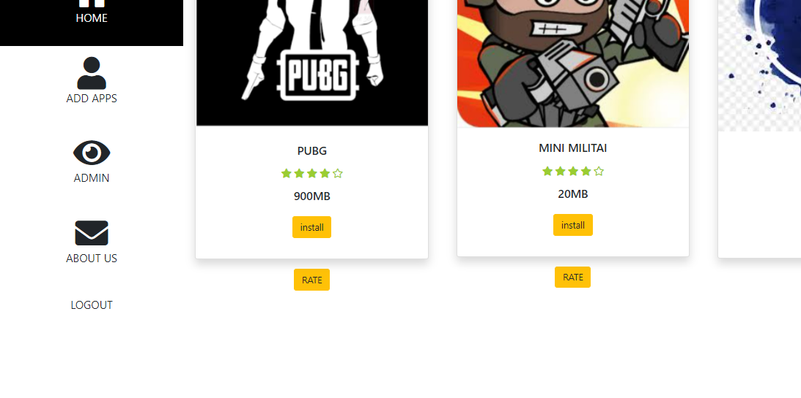

Fig 5.11 log out option for user is shown by arrow mark.

**CHAPTER 6**

**CONCLUSION**

This project is carried out to analyse the internet applications on database management through the use of MySQL and the features of Spring boot and the way it can be used and interfaced with MySQL as a standalone database application.

The **“Housing management”** is the desktop application which can be used by any basic computer user to do real-estate. This application provides the access to the user to create account, Buy or Sell his property and to add the liked property to his wish list. The main objective of this project is to eliminate **brokers** from whole rental scene.

The main focus of developing Housing management is to design an application, which could store property data and provide an interface for retrieving customer related details with much accuracy.

**CHAPTER 7**

**REFERENCE**

* Elmasri and Navathe, Fundamentals of Database Systems, Fourth 2.
* Edition, Addison-Wesley, 2005.
* [www.journaldev.com](http://www.journaldev.com)
* <http://www.w3schools.com>
* www.fontawosem.com